Calculate Profile

The idea behind a slow-moving profiler is to capture the vertical displacement of the system with as few devices as possible. Some vehicle, a cart or a ski, is traveling across the surface. As the vehicle travels, the distance traveled can be found by using a distance encoder with a fixed number of pulses (A) per rotation. The distance of each pulse (dX) can be either calibrated from a test surface or calculated by using the circumference of the wheel

C=(2)(radius)(pi)

dX=C/A

Example:

A wheel with a 0.1 foot inch radius diameter is connected to a distance encoder with 64 pulses per rotation.

C=(2)(0.1)(pi)
C=0.6283
dX=(0.6283)/(64);
dX=0.009817

So, each pulse is 9.82x10-3 feet, or 101.8 pulses per foot.

Alternatively, the vehicle could be run for a distance of 10 feet, and return 1019 readings over the distance. In that case, the pulses per foot would be 101.9, and dX would be 9.81x10-3.

At the same time, a second instrument records the angle of inclination (Theta) of the vehicle at the time the travel distance is measured. So, for each point along the distance of travel, a known angle can be applied to a known path of travel as shown in Figure 1.1. Now, the change in height (dY) can be calculated using the values dX and Theta as shown in figure 1.2

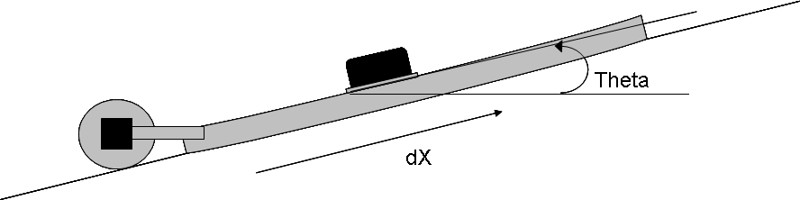
Figure 1.1 The Sliding Profiler
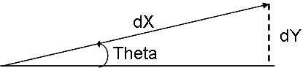

Figure 1.2 Calculating Change in Profile dY

Such that dY=(dX)sin(Theta)

Now, each incremental change in the height is known, to find the current profile with respect to the start position of the vehicle at a given point is the summation of all the profile changes, and the position of the data is the summation of all the distance changes.

Distance = Sigma dX
Profile = Sigma dY
Profile = Sigma (dX)sin(Theta)

Eliminating Bias

Experiments have shown that a certain amount of bias comes into the readings of the inclinometer. This bias can be calculated and removed by using a moving average window of certain length (B) of B profile points calculated immediately before the current profile point (Profile(n)).

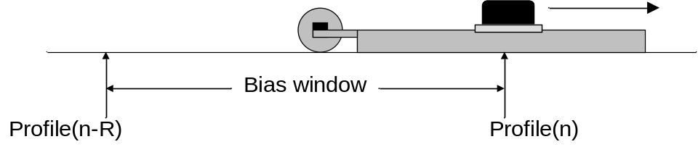
Figure 2.1 Bias window

Bias(n) = Sigma(Profile(n-B) .. Profile(n))/B

And the adjusted profile (AdjProfile) is calculated as follows:

AdjProfile(n) = Profile(n) – Bias(n)

Finding the Running Average

The running average of the profile is used in detecting deformities in the wet concrete.
This running average can be calculated using a moving average window of length R with respect to the point at n-R/2 and where the right most point of the window being the current profile point (Profile(n)).

Running_Average(n-R/2) = Sigma(Profile(n-R) .. Profile(n))/R
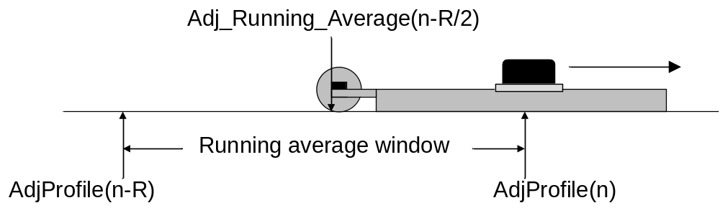
Figure 3.1 Adjusted running average window

Adj_Running_Average(n-R/2) = Sigma(AdjProfile(n-R) .. AdjProfile(n))/R

Finding the Difference

The difference between the adjusted profile(with removed bias) and the running average is used to locate deformities in the fresh concrete.

Difference(n) = abs(AdjProfile(n) – Adj_Running_Average(n))

Detecting the Deformity

A deformity is located in the wet concrete with respect of a pivot point in the running average window. The sliding profiler uses the middle point of the running average window for calculating the deviation of the adjusted profile and the running average. A deviation above certain threshold is considered a bump.

IF Difference(n) > Threshold THEN “There is a deformity at point n.”
ELSE “No deformity”

